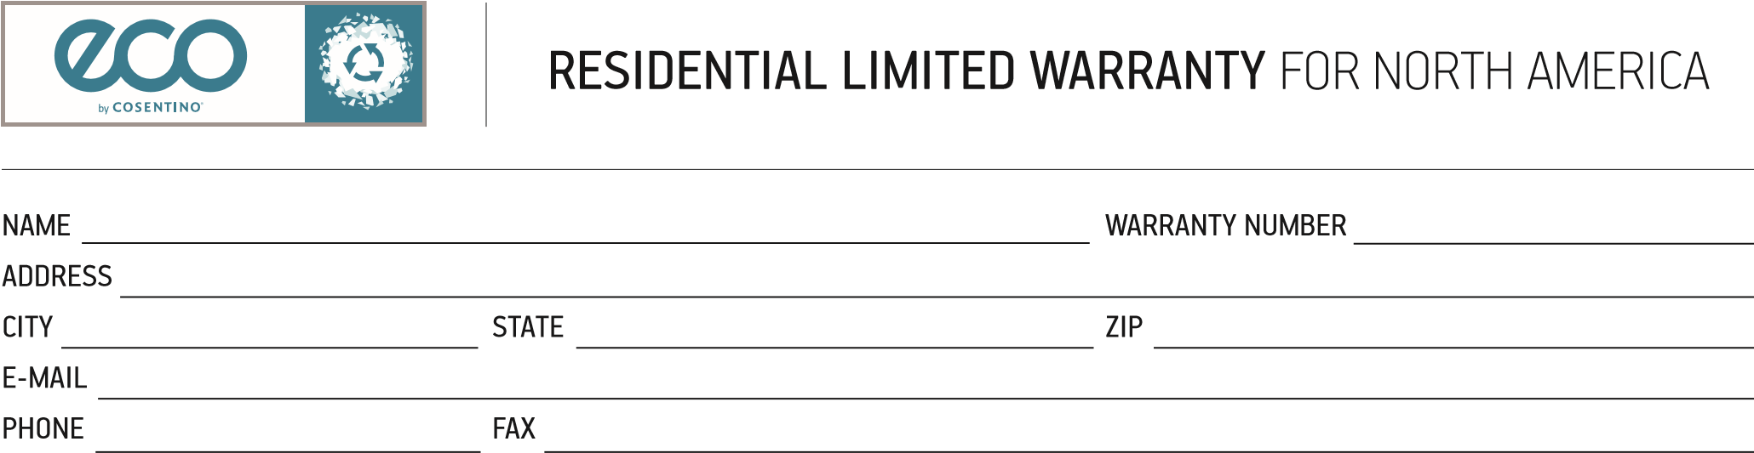
Cosentino, S.A. warrants to the residential owner-occupants of installed Eco® quartz surfaces (“Eco® Surfaces”) that for a period of twenty-five (25) years from the date of installation of the Eco® Surfaces in your single family residential home, that the Eco® material will be free from manufacturing defects. If a manufacturing defect occurs during the warranty period, Cosentino, S.A. will at its option, repair or replace the defective Eco® Surfaces.

WHAT THIS LIMITED 25-YEAR WARRANTY COVER:
- This limited transferrable warranty covers Eco® Surfaces that have been purchased from an Authorized Eco® Installer or Dealer (“Authorized Installer”) and have been permanently installed in your single family residence by an Authorized Installer.
- This limited transferrable warranty covers products that have been maintained according to the Eco® Surfaces Care and Maintenance
WHAT THIS LIMITED 25-YEAR WARRANTY DOES NOT COVER:
✖ Eco® Surfaces are stone products which will not crack unless an external force or interaction causes the crack such as impacts, uneven cabinets or flooring, structural settling or movements, thermal shock from the use of crock pots, skillets or other hot items placed directly on the Eco® Surfaces, improper installation or other conditions in the home that may cause the Eco® Surfaces to shift. Therefore, cracks are not covered by this warranty. Caution: Do not use crock pots, skillets or other hot items directly on your Eco® Surfaces. Always place them on a trivet or cutting board to protect your Eco® from thermal shock.
✖ This warranty does not cover any additional or supplemental repairs or modifications such as, any plumbing, electrical, tile or wall surface modifications that may be necessary to repair or replace the Eco® Surfaces covered under this limited warranty; such other repairs and modifications shall be the responsibility of the customer.
✖ This warranty does not cover products that have not been paid for in full. ✖ This warranty does not cover products exposed to abnormal use or conditions or abuse in any way. “Abnormal use or conditions” includes, but is not limited to, damage from mishandling or misuse, damage from excessive heat, scorching or exposure to weather conditions, exposure to ultraviolet light, physical or chemical abuse, acid etching, staining or damage from improper care and maintenance or damage from chipping, cracking, impact damage or breaking due to customer abuse. ✖ Eco® Surfaces are intended to have a natural and non-uniform appearance, thus this limited warranty does not cover any variances in color, shade, particle structure or gloss level.
✖ This warranty does not cover products that you, the customer, decide you do not like after installation due to color, edging styles or other opinions based on personal preference.
✖ This warranty does not cover seam appearance or performance. ✖ This warranty does not cover temporary marks on the Eco® products including but not limited to metal marks, fingerprints or smudges or other temporary marks made by household utensils.
✖ This warranty does not cover “commercial uses” of the Eco® products. “Commercial uses” include but are not limited to use in commercial buildings such as retail stores, restaurants, offices, hotels, or apartment complexes.
✖ This warranty does not cover outdoor uses.
✖ Cosentino, S.A. is not responsible for damage or injury caused in whole or in part by acts of God, job site conditions, architectural and engineering design, structural settling or movement, acts of vandalism, or accidents.
REGISTRATION, ACTIVATION, TRANSFERING AND OBTAINING SERVICE:
To activate your registered warranty, or to obtain a Transfer of Ownership form, please visit www.cosentinowarranty.com or call or write to Cosentino, S.A.’s North American distributor at the phone number or address below. You must activate your warranty within sixty (60) days of installation to be eligible under this warranty. To transfer this warranty, you must complete, sign and send the Transfer of Ownership form to cs@cosentino.com within sixty (60) days of the transfer of your home. To obtain the best service under this warranty, contact the source from whom the Eco® Surfaces was originally purchased. In order to obtain service under this warranty, you must permit Cosentino North America’s authorized agents to inspect your Eco® Surfaces at your residence. You must reasonably cooperate with the Authorized Installer and Cosentino North America’s agents in the efforts to service this warranty.
For more information about this warranty, please visit www.cosentinowarranty.com. For additional information contact: Cosentino S.A.
Eco® Surfaces
2245 Texas Drive, Suite 600
Sugar Land, TX 77479 USA
Attn: Warranty Administrator
(1-877-436-7482)
Email: cs@cosentino.com
In no event shall Cosentino North America or Cosentino, S.A. be liable in either tort or contract for any loss of direct, consequential, punitive or incidental damages, or any similar damages, including but not limited to loss profits damages, arising out of the use or inability to use the product for residential applications covered by this limited warranty. Some states do not allow the exclusion or limitation of incidental damages, so the above limitation or exclusion may not apply. Neither Cosentino North America nor Cosentino, S.A. make any other warranty, representation or guarantee, express or implied, with respect to Eco® Surfaces for residential use, except as expressly stated herein. This warranty gives you specific legal rights, and you may also have other rights which may vary from state to state or, in Canada, from province to province. This is the only warranty offered by Cosentino, S.A. for Eco® Surfaces for residential applications. No one other than Cosentino, S.A. is authorized to make any warranty or promise with respect to Eco® Surfaces. The 25-year period established in this Letter of Warranty is only applicable to those products that are sold and registered after 1 January 2015.

